26/12/15
THM 348 Service Operations Management
Final Exam Answer Sheet
- Sagna is the quality department manager of “Songy”, a well-known television manufacturing company. In his effort to improve the quality at the company, Sagna prepared SurvQual questionnaire and communicated it to all customers. Upon analysis of said questionnaire, Sagna realized that customers spelled out their dissatisfaction in the following areas along with the frequency of those very problematic areas:

Problem Area | Frequency
Color contrast of the TV | 5
After Sales Service Unavailability | 33
Inadequate Behavior of Call Center Employees | 40
Inadequate Skills / Knowledge of Service Employees | 27
Uncompetitive TV Price Strategies | 4
Slow After Sales Service Response | 10
Prepare a Pareto Chart for the above data. (2 Points)
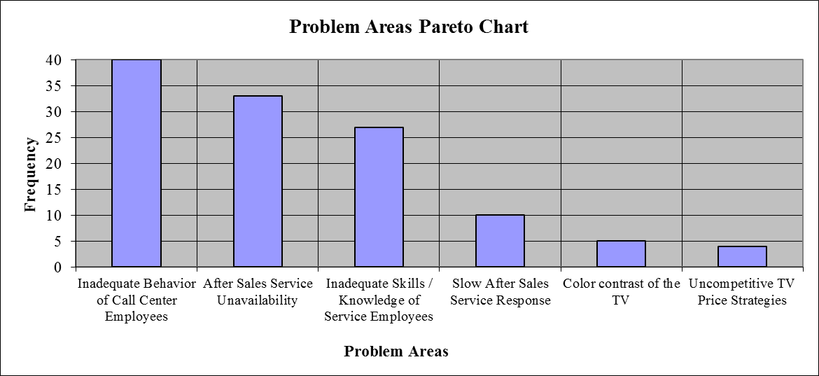

- As “Inadequate Behavior of Call Center Employees” problem had the highest frequency amongst the other problems, Sagna decided to tackle this first. He decide to retrain company’s call center employees on “Behavior Etiquette” related issues psychological support on how to approach a customer. After 12 weeks, he wanted to see if there are any quality improvements in the process. To see this, he decided to use run chart. He prepared the following table depicting monthly related guests’ complaints (before / after training). The following table reveals the following results:
Week | Guest Complaints (Before) | Guest Complaints (After)
1 | 3 | 2
2 | 4 | 2
3 | 3 | 1
4 | 3 | 2
5 | 4 | 3
6 | 2 | 1
7 | 3 | 2
8 | 2 | 2
9 | 4 | 3
10 | 4 | 1
11 | 5 | 3
12 | 3 | 1
Total | 40 | 23
Prepare a run chart to compare guest complaints before and after re-training of call center employees. (2 Points)

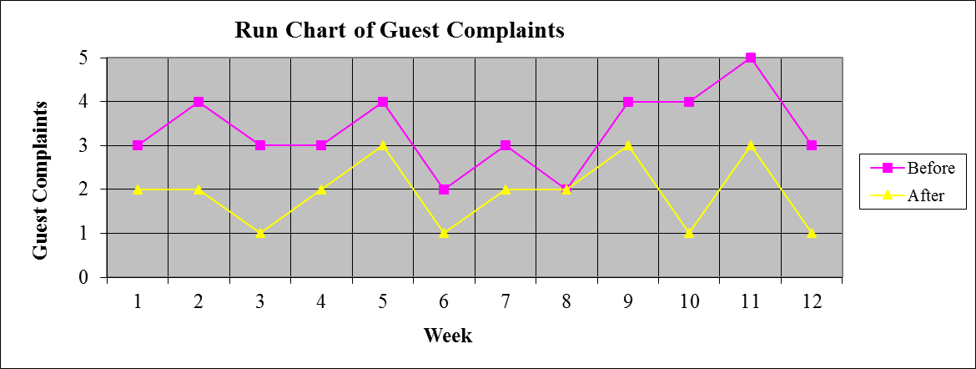
c) Analyze the finding in part b). Is there any improvement as far as guest complaints are concerned after retraining call center employees? If there is an improvement, what is the next problem that Sagna shall try and solve? (1 Point)
As seen from the run chart prepared in part b), there is a clear improvement as far as guest complaints are concerned after retraining call center employees. The next problem that Merlin shall try and solve is “After Sales Services Unavailability”.
- Contrast “Transfer” and “Replacement” strategies to improve productive capacity of the service worker. Provide an example for each of those very strategies. (2 Points)
While “Transfer” is a an approach to make knowledge available to customers so that value can be transferred with very low cost, “Replacement” is a strategy of substituting technology for human resources. An example for transfer strategy can be a web-based Frequently Asked Questions (FAQ) database. An example for replacement strategy can be digital blood pressure measurement device replacing the need to physically go to hospital for nurse assistance in the matter.
- “Grey hair projects require knowledge and judgement, but they can be standardized and repeated”. Do you agree with this statement? Why? Why not? (2 Points)
Yes, I agree with this statement. In fact, since grey hair firms have conducted similar projects before, they gained knowledge and skills from previous projects. Moreover, certain tasks can be predicted and delegated to junior staff.
- “Often franchise contracts favors the franchisee”. Do you agree with this statement? Why? Why not? (2 Points)
No, I don’t agree with this statement. In fact, in franchise contracts, control and power tend to concentrate in the hands of the franchiser. Very often, these very contracts include specific obligations on the part of the franchisee but are ambiguous regarding the responsibilities of the franchiser.
- What are the advantages of “Service Offshoring” What service sectors can better be offshored? (3 Points)
The advantages of service offshoring can be as follows:
- Save labor costs
- Create employment opportunities for service hosting country
Some of the service sectors that can best be offshored are as follows:
- Customer service
- Financial analysis
- Income tax preparation
- Payment services
- Software development
- Research & Development
- During the past season, Salifu Resort Hotel did not achieve very high occupancy rates despite a reservation system that was designed to keep the hotel fully booked. Apparently, prospective guests were making reservations that, for one reason or another, they failed to honor. A review of Front-desk records during the current peak period, when the Resort Hotel was fully booked, revealed the record of no-shows as shown in the below table:
No-shows | Probability | Reservations Overbooked | Cumulative Probability
0 | 0.08 | 0 | 0.00
1 | 0.10 | 1 | 0.08
2 | 0.04 | 2 | 0.18
3 | 0.06 | 3 | 0.22
4 | 0.11 | 4 | 0.28
5 | 0.23 | 5 | 0.39
6 | 0.14 | 6 | 0.62
7 | 0.07 | 7 | 0.76
8 | 0.12 | 8 | 0.83
9 | 0.03 | 9 | 0.95
10 | 0.02 | 10 | 0.98
Suppose that a vacant room (because of No Show) results in an opportunity loss of $ 65.
- Calculate the Expected Number of No Show Rooms. (2 Points)
- Expected Number of No Show Rooms = (0 * 0.08) + (1 * 0.10) + (2 * 0.04) + (3 * 0.06) + (4 * 0.11) + (5 * 0.23) + (6 * 0.14) + (7 * 0.07) + (8 * 0.12) + (9 * 0.03) + (10 * 0.02) = 0 + 0.10 + 0.08 + 0.18 + 0.44 + 1.15 + 0.84 + 0.49 + 0.96 + 0.27 + 0.20 = 4.71 Rooms.
- Calculate the Expected Opportunity Loss. (1 Point)
- Expected Opportunity Loss = 4.71 * 65 = $ 306.15.

In order to avoid some of this loss, Salifu Resort Hotel management is considering an overbooking policy. Yet, if a guest holding a reservation is turned away (due to overbooking), other costs would be incurred. Salifu Resort Hotel has made arrangements with a nearby Resort Hotel (Keita Resort Hotel) to pay for the rooms of guests whom it cannot accommodate. Further, a penalty is associated with the loss of customer goodwill and the impact this has on future business. Management estimates this total loss to be approximately $ 140 per turned out guest.
- Fill the below Overbooking Loss Table (3 Points)
 |  | Reservations Overbooked
No-shows | Prob. | 0 | 1 | 2 | 3 | 4 | 5 | 6 | 7 | 8 | 9 | 10
0 | 0.08 | 0.00 | 140.00 | 280.00 | 420.00 | 560.00 | 700.00 | 840.00 | 980.00 | 1,120.00 | 1,260.00 | 1,400.00
1 | 0.10 | 65.00 | 0.00 | 140.00 | 280.00 | 420.00 | 560.00 | 700.00 | 840.00 | 980.00 | 1,120.00 | 1,260.00
2 | 0.04 | 130.00 | 65.00 | 0.00 | 140.00 | 280.00 | 420.00 | 560.00 | 700.00 | 840.00 | 980.00 | 1,120.00
3 | 0.06 | 195.00 | 130.00 | 65.00 | 0.00 | 140.00 | 280.00 | 420.00 | 560.00 | 700.00 | 840.00 | 980.00
4 | 0.11 | 260.00 | 195.00 | 130.00 | 65.00 | 0.00 | 140.00 | 280.00 | 420.00 | 560.00 | 700.00 | 840.00
5 | 0.23 | 325.00 | 260.00 | 195.00 | 130.00 | 65.00 | 0.00 | 140.00 | 280.00 | 420.00 | 560.00 | 700.00
6 | 0.14 | 390.00 | 325.00 | 260.00 | 195.00 | 130.00 | 65.00 | 0.00 | 140.00 | 280.00 | 420.00 | 560.00
7 | 0.07 | 455.00 | 390.00 | 325.00 | 260.00 | 195.00 | 130.00 | 65.00 | 0.00 | 140.00 | 280.00 | 420.00
8 | 0.12 | 520.00 | 455.00 | 390.00 | 325.00 | 260.00 | 195.00 | 130.00 | 65.00 | 0.00 | 140.00 | 280.00
9 | 0.03 | 585.00 | 520.00 | 455.00 | 390.00 | 325.00 | 260.00 | 195.00 | 130.00 | 65.00 | 0.00 | 140.00
10 | 0.02 | 650.00 | 585.00 | 520.00 | 455.00 | 390.00 | 325.00 | 260.00 | 195.00 | 130.00 | 65.00 | 0.00
Expected | ------- | $306.15 | $257.55 | $229.45 | $209.55 | $201.95 | $216.90 | $279.00 | $369.80 | $474.95 | $604.70 | $740.60
Loss ($)
- How many rooms shall be overbooked? Why? (2 Points)
According to the above overbooking loss table, 4 rooms shall be overbooked, since, this very scenario yields the least expected loss.
N.B: Your answers to parts a), b) c) & d) shall be rounded to the nearest cent.
- List any 3 characteristics that service firms shall possess to apply Yield Management in the sales of their products / services. (3 Points)
The characteristics that service firms shall possess to apply yield management in the sales of their products / services are as follows:
- Relatively fixed capacity
- Ability to segment markets
- Perishable inventory
- Product sold in advance
- Fluctuating demand
- Low marginal sales costs
- High marginal capacity change costs.
Good Luck

